

|  |
| --- |
| **Symposium Plugins** |
| D1: Confidential |
| Paul |
| 30 March 2016 |

Contents

1.0 Introduction 4

1.1 Objective 4

1.2 How will we earn our keep? 4

1.3 USPs 4

2.0 SWOT 5

3.0 Competitors 6

3.1 Team Plugins 6

3.2 Agenda Plugins 8

4.0 Profiles Features 9

4.1 Free Features 9

4.2 Pro Features 9

4.3 Limitations on Free Version 10

4.4 Profiles Fields 10

4.5 Examples of Profile Sections 11

5.0 Agenda Features 17

5.1 Free Features 17

5.2 Pro Features 17

5.3 Limitations of Free Version 18

5.4 Agenda Fields 18

5.5 Examples of Agenda Layouts 19

5.6 API / Bespoke Template Designs 23

6.0 Plugin Site 24

6.1 Licencing 24

6.2 Support 24

6.3 Documentation 24

6.4 GitHib 25

6.5 Future Direction of WordPress to take into account 25

7.0 Marketing and Distribution 26

7.1 Branding 26

7.2 Customer Segmentation 26

7.3 Promotion 27

8.0 Time Scale & Milestones 28

9.0 Financials 29

9.1 How many downloads? 29

9.2 Pricing Model 29

9.3 Plugin Sales Model 30

9.4 Premium Support 32

9.5 Affiliate Deals 32

9.6 Costs 32

# 1.0 Introduction

## 1.1 Objective

The intention is to build two inter-related plugins, provisionally called:

* **Symposium: Agenda** (“Agenda” for short)
* **Symposium: Speaker Profiles** (“Profiles” for short)

**Agenda** will display conference agendas allowing organisers to easily format grids with the key content elements and to order these by time and then by secondary criteria such as stream or location. The free version will format a single event agenda with no streams. The Pro version will enable streams and multiple agenda versions.

Agenda Pro version will also link to the Profiles plugin and enable the display of links to sessions by the speaker in agendas across the site. Sales will be on a per site licence.

**Profiles** will display speaker details, such as name, company, job title, a short session summary with bullet points and links to additional information. The free version will include a few layouts with some basic formatting. The Pro version will add additional styling, display types and ordering options plus the ability to tag speakers for specific events so a short code can display them as one block on your site.

Profiles Pro will also integrate with Agenda to make speaker names in the agenda displays clickable and popup/link to profile information. Sales will be on a per site licence.

## 1.2 How will we earn our keep?

Within the bounds of the free software movement we are none-the-less mindful of the need to pay for development, support etc. We envisage revenue being derived through a number of sources:

1. **Paid ‘Extensions’** adding functionality at cost effective prices. The model here is WooCommerce whose website offers hundreds of extensions generally between $29 and $199
2. **‘Premium’ support** which offers regular updates to the software (i.e. to keep it in line with new WordPress iterations) and premium support (maybe live chat or telephone, certainly email)
3. **Affiliate deals** – e.g. from hosting partners

## 1.3 USPs

I cannot find satisfactory functionality for either task in the current repository so we may be the only plugin delivering these capabilities to event organisers.

# 2.0 SWOT

# 3.0 Competitors

I’ve not been able to find any direct competitors but there are a few related plugins that can be hacked to do most of what an event organiser might want

## 3.1 Team Plugins

These are typically aimed at displaying the ‘Our Team’ content on websites. They are similar in that they contact brief and extended biographical information, a profile photo and can often display sub-groups such as ‘department’.

However, their displays assume all the ‘team’ are within a single organisation and so do not display ‘Company Name’ or ‘Logo’ – which event organisers may want. Also they focus on enabling contact with the team member via email, social links, phone etc. which event organisers may not need or may want to limit.

Examples of team plugins include:

**TLP Team**

*NB – this is the one I am thinking of basing our functionality around*

|  |  |
| --- | --- |
| **Date** | **Downloads** |
| **Repository Link** | <https://wordpress.org/plugins/tlp-team/> |
| **Main Site Link** | <https://radiustheme.com/tlp-team-pro-for-wordpress/> |
| **Active Installs** | 1000+ |
| **Pro Pricing** | 1 site = $14, 5 sites = $49, unlimited sites = $85 |

**Our Team Showcase***NB – we bought this one.*

|  |  |
| --- | --- |
| **Date** | **Downloads** |
| **Repository Link** | <https://wordpress.org/plugins/our-team-enhanced/> |
| **Main Site Link** | <https://smartcatdesign.net/downloads/our-team-showcase/> |
| **Active Installs** | 10,000+ |
| **Pro Pricing** | 1 site = $19, 5 sites = $45, unlimited sites = $69 |

**Our Team by WooThemes**

|  |  |
| --- | --- |
| **Date** | **Downloads** |
| **Repository Link** | <https://wordpress.org/plugins/our-team-by-woothemes/> |
| **Main Site Link** | <https://docs.woothemes.com/documentation/plugins/our-team/>  <https://github.com/woothemes/our-team/> |
| **Active Installs** | 10,000+ |
| **Pro Pricing** | Free |

**Team**

|  |  |
| --- | --- |
| **Date** | **Downloads** |
| **Repository Link** | <https://wordpress.org/plugins/team/> |
| **Main Site Link** | <http://paratheme.com/product/team-responsive-meet-the-team-grid-for-wordpress/> |
| **Active Installs** | 6000+ |
| **Pro Pricing** | 1 site = $14, 2 sites =$25, 5 sites = $50, unlimited sites = $199 |

**Easy Team Manager**

|  |  |
| --- | --- |
| **Date** | **Downloads** |
| **Repository Link** | <https://wordpress.org/plugins/easy-team-manager/> |
| **Main Site Link** | <https://daisythemes.com/easy-team-manager-plugin-wordpress/> |
| **Active Installs** | 1000+ |
| **Pro Pricing** | Free? No pro version |

**Custom Team Manager**

|  |  |
| --- | --- |
| **Date** | **Downloads** |
| **Repository Link** | <https://wordpress.org/plugins/custom-team-manager/> |
| **Main Site Link** | <http://webdevsbd.com/team-members/> |
| **Active Installs** | 1000+ |
| **Pro Pricing** | Free? No pro version |

**TC Team Members**

|  |  |
| --- | --- |
| **Date** | **Downloads** |
| **Repository Link** | <https://wordpress.org/plugins/tc-team-members/> |
| **Main Site Link** | <http://themescode.com/items/tc-team-members/> |
| **Active Installs** | 200+ |
| **Pro Pricing** | 1 site = $12, 2 sites = $20, 5 sites = $40, Unlimited sites = $199 |

**Staff List**

|  |  |
| --- | --- |
| **Date** | **Downloads** |
| **Repository Link** | <https://wordpress.org/plugins/staff-list/> |
| **Main Site Link** | <http://abcfolio.com/wordpress-plugin-staff-list-live-preview-grid-layout/> |
| **Active Installs** | 100+ |
| **Pro Pricing** | $15 |

## 3.2 Agenda Plugins

The only one I can find is:

<https://wordpress.org/plugins/agenda/>

100+ active installs but last updated 8 years ago!

# 4.0 Profiles Features

One possibility is to fork he functionality of an existing team plugin such as TLP Team (see above)

<https://wordpress.org/plugins/tlp-team/screenshots/>

Amending this to add/remove elements we need and redesigning the graphics to cope with the different elements.

## 4.1 Free Features

|  |  |
| --- | --- |
| **Features** | **Notes** |
| Fully Responsive & Mobile Friendly |  |
| 4 Different layouts (3 Grid and 1 Isotope) | Will need redesigns to cover additonal content (Company name and logo) |
| Custom meta filed |  |
| ShortCode | Display single, selected (ID), or all speakers. Choose layout. Order. |
| 3 types of ordering title/ publication date/ menu_order | Maybe add "Organisation" |
| Image Size option |  |
| Widget |  |
| Primary color control |  |
| Detail link (Yes/No) |  |

## 4.2 Pro Features

|  |  |
| --- | --- |
| **Pro Features** |  |
| Total xx Layouts (Grid, Table, Isotope & Carousel). | Will need redesigns to cover additional content (Company name and logo) Like to add pop up for long biog details if not already included Done |
| xx+ Layout variation. |  |
| Unlimited Short Code Generator. | Done |
| Visual Composer compatibility. | Check also works with SiteBuilder by Page Origin Done |
| Drag & Drop ordering. | ? |
| Order by event date / time | Done |
| Order by organisation name | Done |
| Unlimited colour. | Done |
| All fields control show/hide. | We can use custom css for that. Done |
| All text size, colour and text align control. | Done |
| Square / Rounded Image Style. | Done |
| Grid with Margin or No Margin. | Done |
| Social icon, colour size and background colour control. | Done |
| Detail page with Popup and Next Preview button. | Done |
| Skill fields with progress bar. | ???????? |
| Pagination (You can set how many show per page). | Done |
| Member Display by Department(s) wise. | Change "Department" to "Event" (ensure multi select possible) Done |
| Specific Member(s) Display (Select by name in Short Code) | Done |
| Add links to upcoming sessions for speaker in the Agenda plugin | This could link to the agenda and show when you can hear this speaker Done |

## 4.3 Limitations on Free Version

|  |  |
| --- | --- |
| **Limitation** | Note |
| Does not link to Agenda plugin |  |
| Short code feature | Add ability to display all speakers from an event (using Agenda plugin pro) |
| API | To enable theme builders and designers to create their own displays and layouts |

## 4.4 Profiles Fields

Again, developing on from the TLP plugin, I think we would need:

|  |  |
| --- | --- |
| **Available fields** | **Notes** |
|  |  |
| Title/Name (Post Title) | Change to "Speaker Name"? |
| Description (Post Content) | For long biography |
| Short Bio (Custom field) |  |
| Designations (Custom field) | Change to "Role" |
| Email (Custom field) | Optional |
| Personal Web URL (Custom field) | Optional – But change to "Organisation Web URL" |
| Telephone (Custom field) | Optional |
| Location (Custom field) | Optional |
| Social links (FB, Twitter, LinkedIn, Youtube and Google+ ) | Optional |
|  |  |
| WE WOULD WANT |  |
| Organisation Logo |  |
| Organisation Name |  |
|  |  |
| Link to event pages they are speaking at? |  |
|  |  |

## 4.5 Examples of Profile Sections

**Example 1 – Our Current Agenda Style**

The genesis of this project was the need to create agenda designs for our own site at [www.symposium.co.uk](http://www.symposium.co.uk/)

The Agenda below illustrates a typical use case for the event here:

<http://www.symposium.co.uk/event/health-work-summit-2016/>

Note the following:

1. Fairly standard elements
   1. Speaker name
   2. Speaker Job Title
   3. Speaker Organisation
   4. Short biography (could be linked to more detailed version or collapse to reduce space)
   5. Organisation logo
   6. Speaker picture

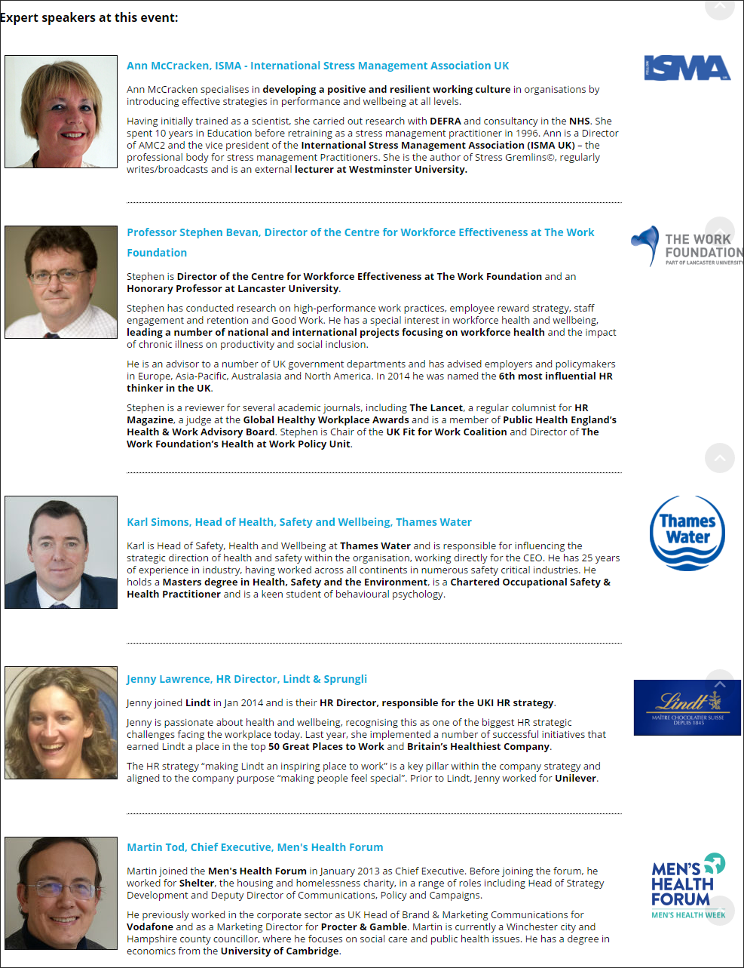

**Example 2 – TLP Team - A typical ‘team’ layout**

This is one example of the range of layouts from **TLP Team** on this page

<http://demo.radiustheme.com/wordpress/tlpteampro/>

**Note** there is no space or location for a **company name or logo** – this is the case with all team plugins that presume the team are all from the same organisation.

Also there is information that *most* event managers won’t use – email, phone, location – as they are not primarily interested in allowing readers to contact the speaker but rather in **demonstrating why the speaker is qualified to present on the topic and what they add to the event.**

In this respect the ‘skills’ bars at the bottom of this example could be a nice touch for event organisers to highlight the speaker’s expertise.

Note use of mouse over effects to reveal more information/social links.

*This may be the plugin we base our functionality around?*

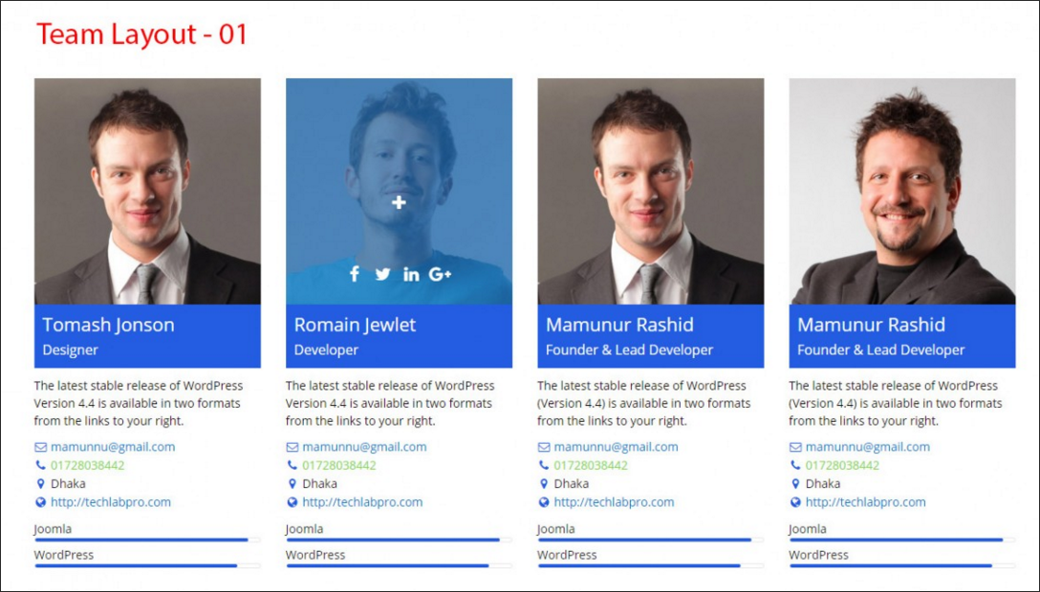

**Example 3 – Our Team Showcase**

This example is from Our Team Showcase which we bought to use ourselves.

Again, no space for organisation name or logo.

However, I very much like the quote feature. An example of something similar at a real conference can be found here <http://www.impact13.com/presenters/>

But it does take up a lot of real estate.

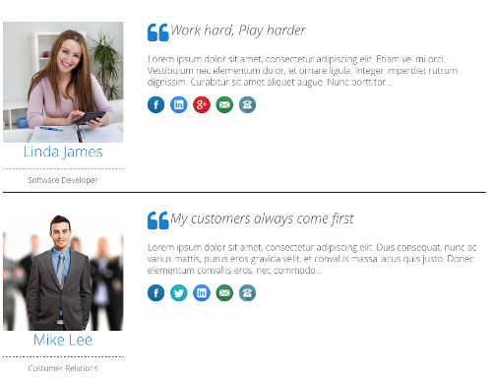

**Example 4 – Minimal**

Speaker information is often displayed in two places – as a full page devoted solely to the speaker’s biographies or as a summary of the speakers on the event’s main landing or marketing page. A summary example might look like this:

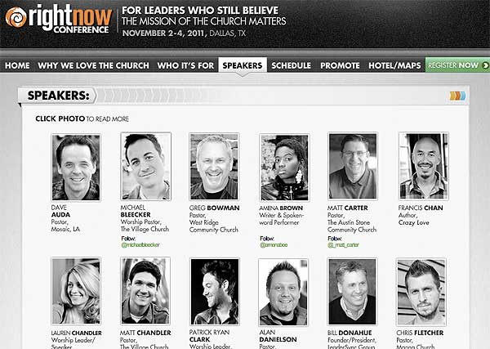

**Example Five – The With Logos**

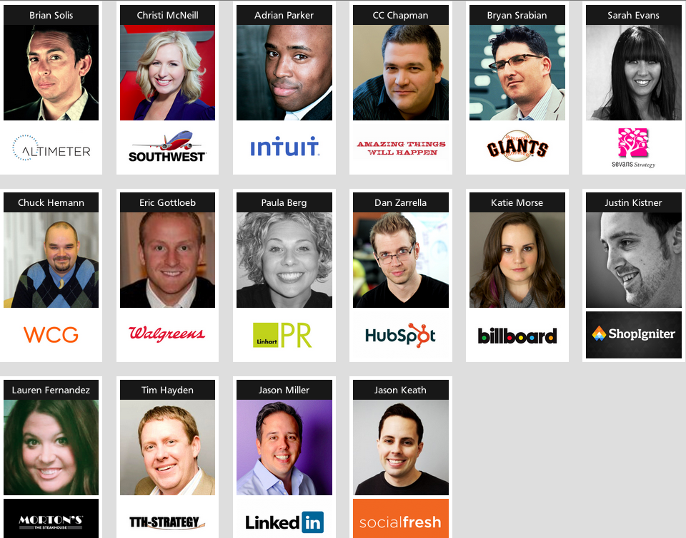

**Example 6 – The Keynote**

Also on occasion, you do see some speakers picked out and given larger profiles – usually because they are a key note speaker, guru, famous etc.

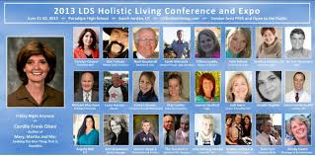

# 5.0 Agenda Features

## 5.1 Free Features

|  |  |
| --- | --- |
| **Feature** | **Notes** |
| Fully Responsive & Mobile Friendly | *Done* |
| Layouts (Grid and 1 Isotope?) | Simple Grid = Time | Session (FREE VERSION) Complex Grid = Time | Session | stream/room (PRO VERSION) |
| Custom meta filed | *Done* |
| ShortCode | *Done* |
| Order by Start time | Later we might add order by session name, speaker, organisation? |
| Image Size option | Option image? Maybe speaker pic or logo *Done* |
| Widget | Develop later if needed? |
| Primary color control | *Done* |
| Detail link (Yes/No) | Link??? |

## 5.2 Pro Features

|  |  |
| --- | --- |
| **Feature** | Notes |
| xx Layouts (Grid, Table, Isotope & Expanable concertina). | Like to add pop up for long biog details |
| xx Layout variation. |  |
| Show/Hide Details Concertina | + to reveal details, - to just show times and session title Done |
| Visual Composer compatibility. | Check also works with SiteBuilder by Page Origin Done |
| Unlimited color. | Done |
| All fields control show/hide. |  |
| All text size, color and text align control. | Done |
| Row background colours | Done |
| Square / Rounded Image Style. | ? Done |
| Adjust margins and padding |  |
| Social icon, color size and background color control. | Done |
| Order and style speaker details | Decide order of **Speaker name, job title,** *organisaton* or (and indendently stlye each) |
| Style bullet points? | Done |
|  |  |
| Resources / Downloads links | Use to link slide presentations, pdfs etc |
| Speaker Biog links | Free version links to fields but Pro version also can pull from the Speakers plugin  Done |
| Ability to divide agenda into streams /workshops | See "Layouts" above |
| Location / Room | Option to display in listing, use as column header and make live link to map or location details *Done* |
| Plenary sessions / breaks rows | Content row fits across all columns |
| API | To enable theme builders and designers to create their own dsiplays and layouts |

## 5.3 Limitations of Free Version

|  |
| --- |
| **Limitation on Free version** |
| Cannot link to Speakers plugin - all speaker data fields need completing manually within the Agenda Plugin and cannot open more details |
| Only one live event agenda - pro version will allow multiple agendas |
| Single agenda - ie no break-outs or muliple parrallel sessions |

## 5.4 Agenda Fields

|  |  |
| --- | --- |
| **Fields** | **Notes** |
| **Event Level** |  |
| Event name |  |
| Event shortcode | Show the shortcode to insert this event agenda anywhere |
| Event date(s) | Optional |
| Event Code / SKU |  |
|  |  |
|  |  |
| **Session Level** |  |
| Session Title |  |
| Session Start Time |  |
| Session End Time |  |
| Detailed Description | Anything - maybe use the main post content field? |
| Brief Description | Typically one sentence and three-six bullet points *NB - Ability to style bullet points could be important so may need extra functionality for that?* *Done* |
| Speaker Name | Pro version links to Speaker plugin and gives drop down or speakers to pull this information from Also pro version turns this into a link and will pop up/link to choice of Brief or Full biography Done |
| Role | Pro version links to Speaker plugin and gives drop down or speakers to pull this information from Done |
| Organisation Name | Pro version links to Speaker plugin and gives drop down or speakers to pull this information from Done |
| Organisation logo | Pro version links to Speaker plugin and gives drop down or speakers to pull this information from Done |
| Room / location | Text field - Can display agenda in columns by room in pro-version |
| Room / location | Link field - use case - download a map to find the location |
| Stream | Can display agenda in columns by stream in pro-version |
|  |  |
| Select session is a break / plenary | Pro feature - would display the session across the whole width agenda table - Lunch, Coffee, Chair's Opening (like merged field in an excel row) |

## 5.5 Examples of Agenda Layouts

**Example 1 – Our Current Agenda Style**

The genesis of this project was the need to create agenda designs for our own site at [www.symposium.co.uk](http://www.symposium.co.uk/)

The Agenda below illustrates a typical use case for the event here:

<http://www.symposium.co.uk/event/health-work-summit-2016/>

Note the following:

1. Fairly standard elements
   1. Session title
   2. Session Details (often bullet points, occasionally not included)
   3. Speaker name (could be linked to biog)
   4. Speaker Job Title
   5. Speaker Organisation (could be linked to webpage)
   6. Logo for speaker organisation could be included in some designs
   7. Sponsor name/logo could be included in some designs
2. Use of font colour and weight to pick out elements
3. Principal organisational division is by session time
4. Use of breaks to visually divide up the day
5. Use of background colour to separate sessions
6. Split into two streams at 11.25 with separate time column for each stream (some advanced designs may allow different session lengths(?) – others could keep a single time column)
7. Recombining of streams at 12.25
8. Another advanced/pro design might collapse to show only session time/title

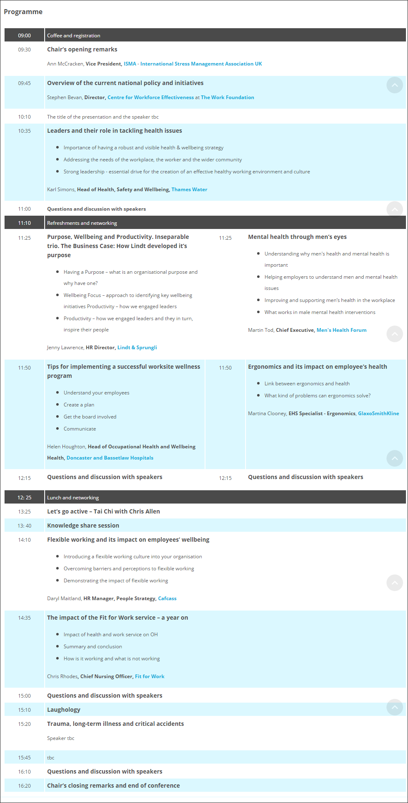

**Example 2 – Simple use of Rooms to stream content across the day**

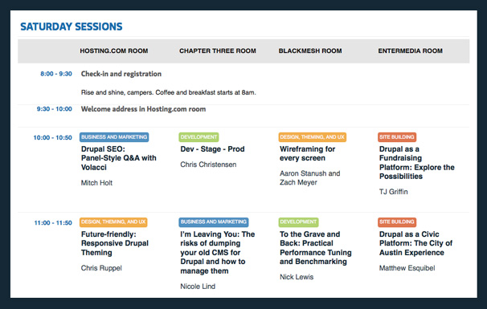

**Example 3 – More complex layout**

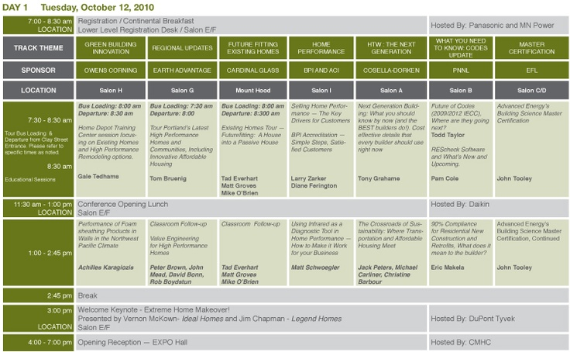

**Example 4 – showing non-parallel session times (green blocks)**

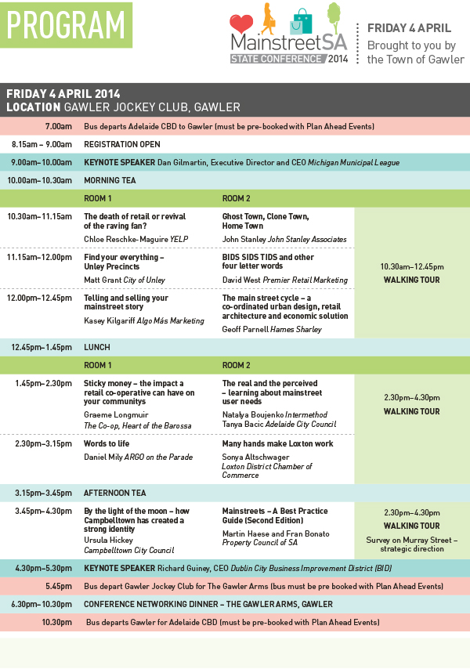

**Example 5 – Showing use of separate cell colours**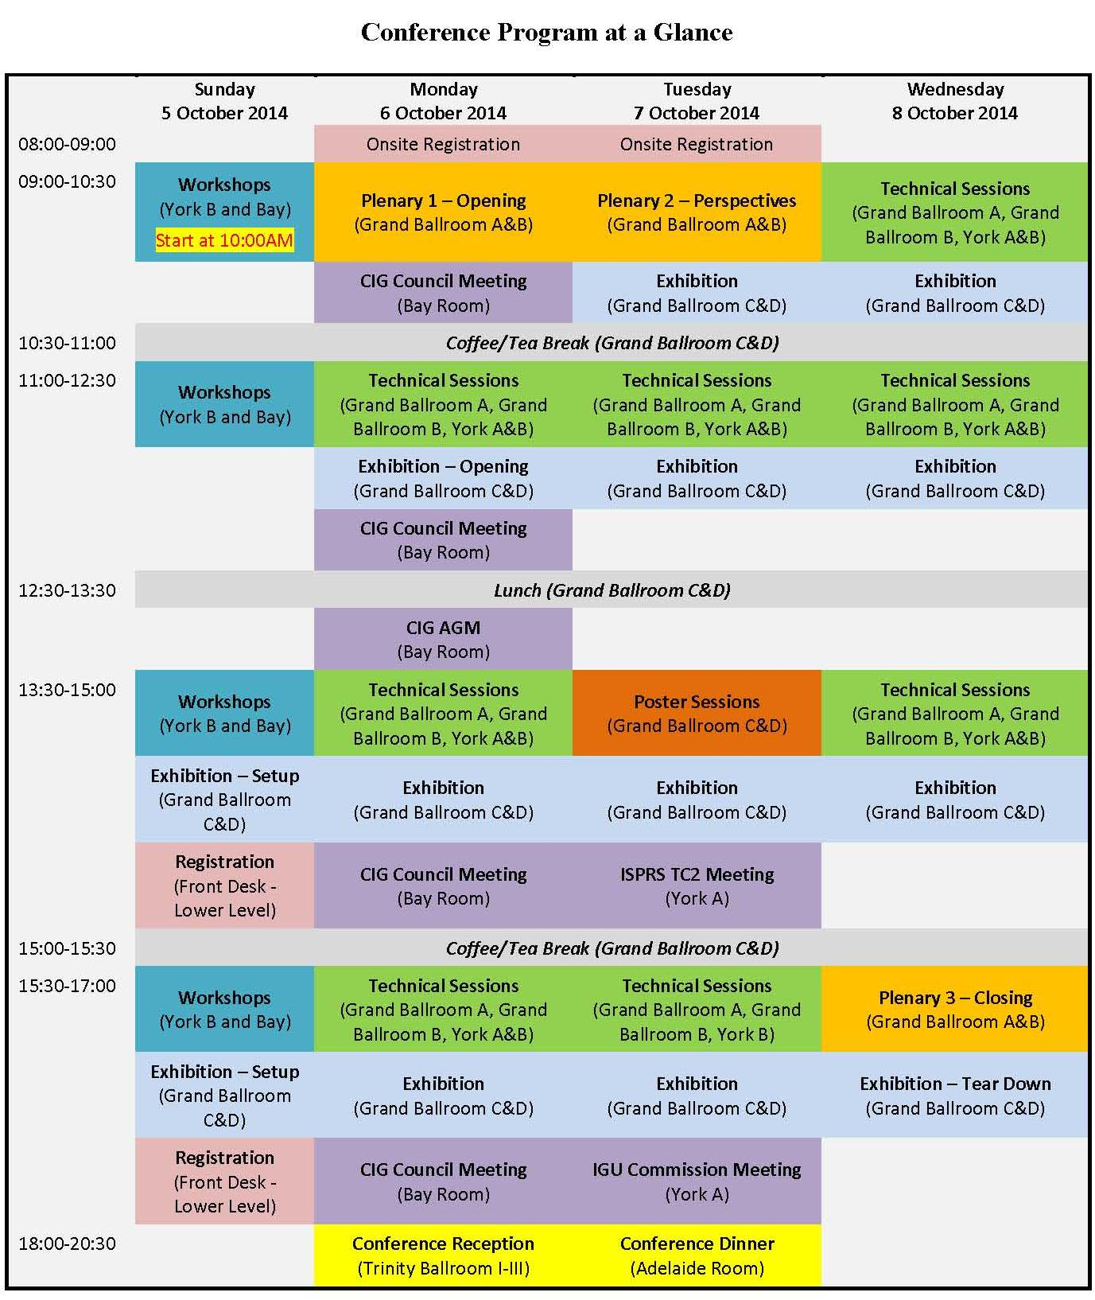

## 5.6 API / Bespoke Template Designs

The intention is to provide a small selection of layout designs / templates with some tailoring of elements like font, cell/row colour etc. that can be implemented by an event producer with limited design or web skills.

In order to empower programmers and web designers to build their own templates and designs I wonder if we could create an API the allowed the individual styling of elements of the agenda?

# 6.0 Plugin Site

We need a plugin site to manage sales, licences and support

We currently intend this functionality to be located at:

[www.bwtl.co.uk](http://www.bwtl.co.uk/)

## 6.1 Licencing

Ecommerce functions to be provided by WooCommerce with software licencing managed via the [WooCommerce API Manager](https://www.woothemes.com/products/woocommerce-api-manager/).

Subject to any restrictions on source code, we intend to use the GPL licence for the free versions. Elements of the pro versions may be copyright – to be confirmed.

<http://www.gnu.org/licenses/gpl.html>

## 6.2 Support

We will need to provide support.

**Levels of Support**

1. Answering queries in the support forum of the repository – this will be the most we do for free users?
2. Hosting our own forum for licenced user community
3. Answering direct emails?
4. Phone support?
5. Direct client site interventions?

*We are interested in discussing options and costs with the plugin developer for the on-going provision of support.*

## 6.3 Documentation

Some initial documentation should be provided by the developer.

**Owner’s manual**

Covering aspects of the plugin that Black and White Trading may need to understand.

**User Guide**

For end users – how to install, configure and use the plugins.

May include examples of short codes, hooks, tweaks etc.

## 6.4 GitHib

GPL licenced software to be hosted at Black and White Trading Ltd’s GitHub page

<https://github.com/BlackandWhiteTradingLtd>

## 6.5 Future Direction of WordPress to take into account

Somethings to note about working with WP – based on Matt Mullenweg’s State of the Word address December 2015:

* All plugins automatically available for translation via WP
* The future of WordPress is JavaScript interfaces with PHP APIs - driven interfaces (decouple data from the interface)

*“Learn JavaScript – Deeply”* MM

# 7.0 Marketing and Distribution

## 7.1 Branding

We’ll probably link the branding to [Symposium](http://www.symposium.co.uk/) brand (trial deployment will be here) and use iconography like this…

 

**Profiles**  **Agenda**

**Initial colour palate:**

|  |  |  |  |  |
| --- | --- | --- | --- | --- |
|  | **Pantone** | **RGB** | **Web** | **Colour** |
|  | | | | |
| Grey (font?) | Pantone Solid Coated 7540 ? | 74, 74, 74 | #4a4a4a |  |
| Orange | Pantone 1575C | 248, 158, 89 | #f89e59 |  |
| Green | Pantone 383C | 178, 187, 28 | #b2bb1c |  |
| Blue | Pantone 312C | 0, 174, 219 | #00aedb |  |
| Purple | Pantone 252C | 191, 130, 185 | #bf82b9 |  |
| Turquoise | Pantone 3395C | 93, 194, 165 | #5dc2a5 |  |

## 7.2 Customer Segmentation

**Function**

1. **Owner Managers** running events and training companies
2. **Event Managers** teams looking to self-manage elements of their event website
3. **IT professionals** needing to implement functionality for clients (in-house or external)

**Geographic**

Any

**Size of Organization**

Any

## 7.3 Promotion

**WordPress Plugin Repository**

The main channel for marketing – free versions should lead to paid upgrades.

**Website**

Our website could host a blog on events related tips? Promote blogs in social media.

**PR**

Will invite reviews and publicize to event management plugins asking them to write us up in their blogs and join our affiliate scheme – we provide complimentary niche functionality so some should be happy to work with us.

# 8.0 Time Scale & Milestones

Key: Designer BWTL – add notes and target dates below

|  |  |  |  |  |  |  |  |  |  |
| --- | --- | --- | --- | --- | --- | --- | --- | --- | --- |
|  |  | Stage 1 | Stage 2 | Stage 3 | Stage 4 | Stage 5 | Stage 6 | Stage 7 | Stage 8 |
| **Profiles:** Aim to adapt existing “Team” plugin to deliver ‘speaker’ functionality to event organizers and their web-designers - and integrate this with ‘Agenda’ plugin | | | | | | | | | |
|  |  |  |  |  |  |  |  |  |  |
| Recruitment |  |  |  |  |  |  |  |  |  |
| Discovery / Risks / Options |  |  |  |  |  |  |  |  |  |
| Development |  |  |  |  |  |  |  |  |  |
| Prototype 1 |  |  |  |  |  |  |  |  |  |
| Quality and User testing |  |  |  |  |  |  |  |  |  |
| Candidate release to WP |  |  |  |  |  |  |  |  |  |
| Feedback/ amends |  |  |  |  |  |  |  |  |  |
| Accepted in WP Repository |  |  |  |  |  |  |  |  |  |
| V1.0 Pro on sale |  |  |  |  |  |  |  |  |  |
| **Agenda:** Aim is to create a plugin to nicely display event agendas, integrated with ‘Profiles’ plugin and offering (API?) tools for designers to develop their own layouts | | | | | | | | | |
|  |  |  |  |  |  |  |  |  |  |
| Recruitment |  |  |  |  |  |  |  |  |  |
| Discovery / Risks / Options |  |  |  |  |  |  |  |  |  |
| Development |  |  |  |  |  |  |  |  |  |
| Prototype 1 |  |  |  |  |  |  |  |  |  |
| Quality and User testing |  |  |  |  |  |  |  |  |  |
| Candidate release to WP |  |  |  |  |  |  |  |  |  |
| Feedback/ amends |  |  |  |  |  |  |  |  |  |
| Accepted in WP Repository |  |  |  |  |  |  |  |  |  |
| V1.o Pro on sale |  |  |  |  |  |  |  |  |  |
| **Management:** Aim is to set up license management, ecommerce and support infrastructure for the products above | | | | | | | | | |
|  |  |  |  |  |  |  |  |  |  |
| Set up website |  |  |  |  |  |  |  |  |  |
| Licensing systems setup |  |  |  |  |  |  |  |  |  |
| Design sales pages |  |  |  |  |  |  |  |  |  |
| Agree support model |  |  |  |  |  |  |  |  |  |
| Set-up support pages |  |  |  |  |  |  |  |  |  |
| Documentation |  |  |  |  |  |  |  |  |  |
| Github |  |  |  |  |  |  |  |  |  |
| Testing |  |  |  |  |  |  |  |  |  |
| Launch |  |  |  |  |  |  |  |  |  |